fps112

A fully 3D Doom clone

Competitive Analysis

Most 15-112 term project first person shooters I have seen have used raycasting. Raycasting is a compelling technique for this sort of project, but full 3D rendering allows for greater flexibility and verticality. The main gamemode for this project will be a randomly-generated maze of rooms, with enemies and an exit.

Structural Plan

The 3D components will be separated into their own file. Mesh objects, with a number of polygons, are drawn individually. They are currently given automatically generated hitboxes, but that may be changed if needed.

Algorithmic Plan

The most complex part of the project is of course the 3D components, and they are already done! It is difficult to explain the majority of it, but it is using traditional methods, with polygons having 3D coordinates and using linear algebra to project them into screen space. There is a clipping algorithm employed, backface culling, and very basic lighting. Also in this project, Kruskal’s algorithm is used to generate a maze.

Timeline Plan

I am slightly behind schedule on TP1, but the actual core gameplay should be at least partially implemented by then. I plan to have the entire core game done by TP2, but little issues have a way of popping up, as one would expect with the complexity of 3D. I am hoping to attempt to implement networked multiplayer with sockets between TP2 and TP3 if all goes to plan.

Version Control Plan

It’s on Github with the rest of my 15-112 work in a private repository. Look, see?

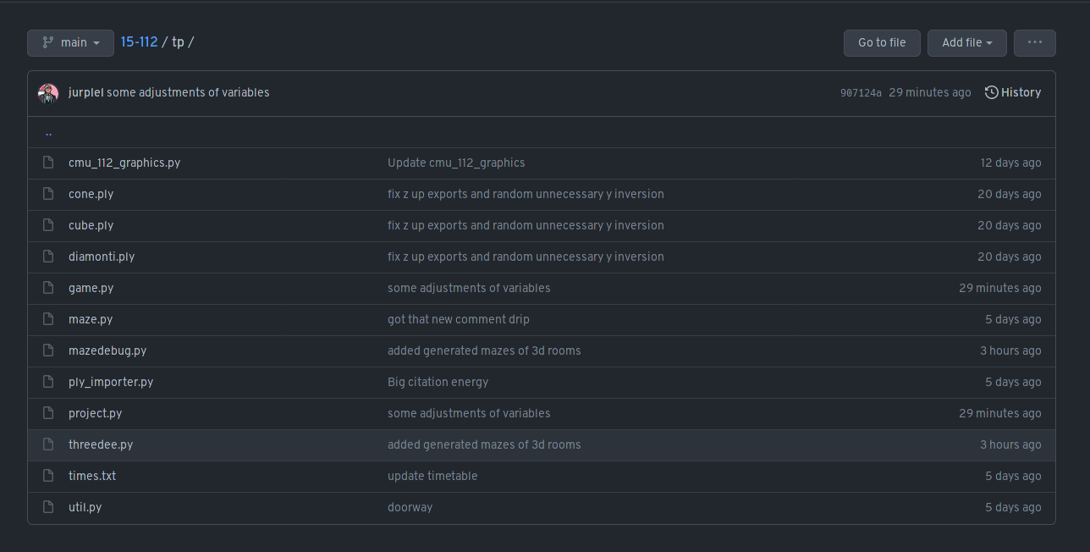

Module List

* NumPy
* Sockets/TCP possibly later

TP2 Update

Instead of an exit to the maze, there will be a boss to defeat, and the boss will drop a diamond item which is the victory condition for the player.

TP3 Update

Multiplayer made it in—functional, playable, even a little fun! Client-server model but the client is really the authority...not exactly cheat-proof. Menu logo is now in full 3D. Music has been added. Many sound effects have been added, most of them from Doom. Weapon sprites have been added, mostly from Doom mods but all but the pistol have been edited in some way. A nicer HUD has been added. There are many gameplay tweaks, including sprinting with the world’s most inconvenient key because shift cant really be used properly. Oh, and weapon switching/multiple weapons are now in the game—weapon upgrades can be found in the other two corners of the maze. Many more small polish-y quality of life-y things too, like you can now press Esc to leave the game and go back to the menu. Configurable options have been added in the form of a JSON because tkinter widgets on top of tkinter canvas is just too much fuss. Weapons have damage falloff over range, as well as other unique characteristics that make them all have a different playstyle. Probably more but that’s all I can remember.